|  |  |
| --- | --- |
| **Question**   |  | | --- | | **Create the media API in android to play an audio file.** | |
| **Activity_main.xml**  *<?***xml version="1.0" encoding="utf-8"***?>* <**RelativeLayout xmlns:android="http://schemas.android.com/apk/res/android"  xmlns:app="http://schemas.android.com/apk/res-auto"  xmlns:tools="http://schemas.android.com/tools"  android:layout_width="match_parent"  android:layout_height="match_parent"  tools:context=".MainActivity"**>   <**Button  android:id="@+id/btnPlay"  android:layout_width="197dp"  android:layout_height="75dp"  android:layout_alignParentEnd="true"  android:layout_alignParentRight="true"  android:layout_alignParentBottom="true"  android:layout_marginEnd="87dp"  android:layout_marginRight="87dp"  android:layout_marginBottom="468dp"  android:text="Play Audio"**  **android:onClick="playAudio"**  />   <**Button  android:id="@+id/btnStop"  android:layout_width="208dp"  android:layout_height="70dp"  android:layout_alignParentEnd="true"  android:layout_alignParentRight="true"  android:layout_alignParentBottom="true"  android:layout_marginEnd="89dp"  android:layout_marginRight="89dp"  android:layout_marginBottom="356dp"  android:text="Stop Audio"**  **android:onClick="onPause"**/>   <**ImageView  android:id="@+id/imageView"  android:layout_width="wrap_content"  android:layout_height="wrap_content"  app:srcCompat="@color/colorAccent"** />   <**ImageButton  android:id="@+id/imageButton5"  android:layout_width="wrap_content"  android:layout_height="wrap_content"  android:layout_alignParentEnd="true"  android:layout_alignParentRight="true"  android:layout_alignParentBottom="true"  android:layout_marginEnd="66dp"  android:layout_marginRight="66dp"  android:layout_marginBottom="182dp"**  **android:visibility="invisible"  app:srcCompat="@drawable/songs"  tools:visibility="invisible"** />  </**RelativeLayout**> |
| **Main_Activity.java**  **package** com.maharashtracollege.profmohdshahid;  **import** androidx.appcompat.app.AppCompatActivity;  **import** android.media.MediaPlayer; **import** android.os.Bundle; **import** android.view.View; **import** android.widget.ImageButton; **import** android.widget.Toast;  **public class** MainActivity **extends** AppCompatActivity {   MediaPlayer **mediaPlayer**;  ImageButton **ibtn**;  @Override  **protected void** onCreate(Bundle savedInstanceState) {  **super**.onCreate(savedInstanceState);  setContentView(R.layout.***activity_main***);  **mediaPlayer** = MediaPlayer.*create*(**this**,R.raw.***myaudio***);  }  **public void** playAudio(View v)  {   **ibtn** = findViewById(R.id.***imageButton5***);  **ibtn**.setVisibility(View.***VISIBLE***);   **mediaPlayer**.start();  Toast.*makeText*(**this**, **"Music is playing, Connect Ear Phone to Listen the Ringtone"**, Toast.***LENGTH_SHORT***).show();  }  **public void** onPause(View v)  {  **super**.onPause();  **mediaPlayer**.release();  **ibtn**.setVisibility(View.***INVISIBLE***);  } } |

Note: For this practical we to copy the .mp3 file and create the folder raw in the res as follows .

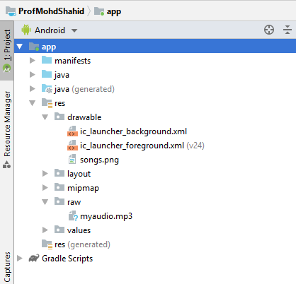

songs.png is used for display and image on in image button

myaudio.mp3 is used to audio playing

|  |  |
| --- | --- |
|  |  |